LUBRICATING OIL AS DEMULSIFIER FOR DEMULSIFICATION OF OIL WATER EMULSION

**A THESIS**

**PP5411**

***Submitted by* AKASH P (2021409026)**

***in partial fulfillment for the award of the degree of***

# MASTER OF TECHNOLOGY IN

**PETROLEUM REFINING AND PETRO CHEMICAL**



# DEPARTMENT OF CHEMICAL ENGINEERING ANNA UNIVERSITY, CHENNAI-600 025 AUGUST 2023

ANNA UNIVERSITY, CHENNAI

# BONAFIDE CERTIFICATE

Certified that this Thesis titled “**LUBRICATING OIL AS DEMULSIFIER FOR DEMULSIFICATION OF OIL WATER EMULSION**” is the bonafide work of **AKASH P (2021409026)** who carried out the work under my supervision. Certified further thatto the best of my knowledge the work reported herein does not form part of any other thesis or dissertation based on which a degree or award was conferred on an earlier occasion on this or any other candidate.

|  |  |
| --- | --- |
| **Dr. K. V. RADHA**  Professor and Head Department of Chemical Engineering  Anna University Chennai – 600 025 | **Dr. K. V. RADHA**  Professor  Department of Chemical Engineering Anna University  Chennai – 600 025 |
| **INTERNAL EXAMINER** | **EXTERNAL EXAMINER** |

# ACKNOWLEDGEMENT

I convey my gratitude to **DR. K. V. RADHA**. Professor, Department of Chemical Engineering A.C. College of Technology. Anna University for her relentless guidance, support and encouragement for my project work.

I wish to articulate my sincere thanks to **Dr. R. JAYAVEL**. Dean, A.C. College of Technology. Anna University for encouraging me to take sustained interest in academic pursuit

It is a great pleasure to express my heartfelt thanks again to **Dr. K. V. RADHA**, Professor and Head. Department of Chemical Engineering. A.C. College of Technology. Anna University for providing me the facilities extended.

I express my sincere thanks to the project review panel members **Dr k. v. RADHA** Professor, **Dr LIMA ROSE MIRANDA** professor, **Dr N. NAGENDRA GANDHI** professor, **Dr K. CHITHRA** professor**, Dr P. GOMATHI PRIYA** professor, **Dr N. BALASUBRAMANIAN** professor, and **Dr V. SIVAKUMAR** professor, Department of Chemical Engineering. A.C. College of Technology. Anna University for their invaluable suggestions that helped to improve my dissertation.

I thank the Research Scholars of Bioproducts Lab for their assistance, kind co- operation and making the resources available for carrying out the project.

**AKASH P (2021409026)**

# ABSTRACT

Petroleum product-based materials have gained significant interest in replacing the petroleum-based oil chemicals with environmentally friendly materials. A lubricating oil- based demulsifier has been successfully synthesized by the condensation reaction of lubricating oil with diethanolamine in the presence of a catalyst applied during separation via a water-in-oil (W/O) emulsion. The demulsifier was characterized by FTIR, GC-MS, and SEM analyses. The surfactant’s separation efficacy was studied using the bottle test. The results showed that this new product efficiently demulsified the W/O emulsion with 98% separation achieved. The influence of settling time, demulsifier dosage, temperature on the demulsification efficiency, effect of salt were investigated. The separation efficiency increased with increasing settling time, demulsifier dose, the temperature conditions and effect of salt accelerate the demulsification process. As well, the interfacial tension decreases with increases of the demulsifier dose.

Keywords:

Water in oil emulsion, lubricating oil, demulsification, crude oil, separation of

water.

சுருக்கம்

பெட்ரோலியம் சார்ந்த எண்ணெய் இரசாயனங்களை சுற்றுச்சூழலுக்கு உகந்த பொருட்களுடன் மாற்றுவதில் பெட்ரோலியம் தயாரிப்பு சார்ந்த பொருட்கள் குறிப்பிடத்தக்க ஆர்வத்தை பெற்றுள்ளன. நீர்-எண்ணெய் (W/O) குழம்பு மூலம் பிரிக்கும் போது பயன்படுத்தப்படும் ஒரு வினையூக்கியின் முன்னிலையில் டயத்தனோலமைனுடன் மசகு எண்ணெயின் ஒடுக்க வினையின் மூலம் ஒரு மசகு எண்ணெய் அடிப்படையிலான டிமல்சிஃபையர் வெற்றிகரமாக ஒருங்கிணைக்கப்பட்டது. டெமல்சிஃபையர் FTIR, GC-MS மற்றும் SEM பகுப்பாய்வுகளால் வகைப்படுத்தப்பட்டது. பாட்டில் சோதனையைப் பயன்படுத்தி சர்பாக்டான்ட்டின் பிரிப்பு திறன் ஆய்வு செய்யப்பட்டது. இந்த புதிய தயாரிப்பு W/O குழம்பை 98% பிரிப்புடன் திறம்பட நீக்கியது என்று முடிவுகள் காட்டுகின்றன. தீர்வு நேரத்தின் தாக்கம், டெமல்சிஃபையர் டோஸ், டெமல்சிஃபிகேஷன் செயல்திறனில் வெப்பநிலை, உப்பின் விளைவு ஆகியவை ஆராயப்பட்டன. பிரிப்புத் திறன் அதிகரித்து தீர்வு நேரம், டீமல்சிஃபையர் டோஸ், வெப்பநிலை நிலைகள் மற்றும் உப்பின் விளைவு ஆகியவை டீமல்சிஃபிகேஷன் செயல்முறையை துரிதப்படுத்துகின்றன. அத்துடன், டெமல்சிஃபயர் டோஸ் அதிகரிப்பதன் மூலம் இடைமுகப் பதற்றம் குறைகிறது.

முக்கிய வார்த்தைகள்:

எண்ணெய் குழம்பில் உள்ள நீர், மசகு எண்ணெய், நீக்குதல், கச்சா எண்ணெய், பிரித்தல், தண்ணீர்.

**TABLE OF CONTENT**

|  |  |  |
| --- | --- | --- |
| **CHAPTER NO.** | **TITLE**  **ACKNOWLEDGMENT** | **PAGE NO.**  **Iii** |
|  | **ABSTRACT (english)** | **Iv** |
|  | **ABSTRACT (tamil)** | **V** |
|  | **List of symbols** | **Viii** |
|  | **List of figures** | **Ix** |
| **1** | **List of tables**  **INDRODUCTION** | **X**  1 |
|  | 1.1 Characterstics of light crude oil | 2 |
| **2** | **LITERATURE REVIEW** | 3 |
|  | 2.1 Research gap | 4 |
|  | 2.2 Aim | 5 |
|  | 2.3 Objective | 5 |
| **3** | **MATERIALS AND METHODS**  3.1 Materials | 5 |
|  | 3.2 Emulsion preparation | 6 |
|  | 3.3 lubrication oil based resin | 7 |
|  | 3.4 Experimental setup  3.5 instrumental analysis | 7 |
| **4** | **RESULT AND DISCUSSION** | 8 |

4. Characterization 8

4.1.1 Fourier transform infrared

spectroscopy 8

4.1.2 Scanning electron microscope-

Emulsion 10

4.1.3 Gas chromatography mass

Spectrometry- lubricating oil

4.2 Parametric Optimization – bottle

Separation method 13

4.2.1 Effect of demulsifier dosage on the

separation perfomence 13

4.2.2 Effect of settling time 15

4.2.3 Influence of temperature 16

4.2.4 Interfacial tension measurement 18

4.2.5 Effect of salinity 20

4.3 Scanning electron microscope

For bed 21

4.4 Effect of flow rate 21

4.4.1 Effect of bed height 22

4.4.2 Effect of temperature on coalscence

Column 24

4.5 Determination of density 25

4.5.1 Determination of viscosity 25

4.5.2 Determination of porosity 26

4.5.3 Determination of sphericity 27

4.5.4 Determination of superficial velocity 27

4.5.5 Pressure drop across the

Coalscer column 28

1. **CONCLUSION 30**

**REFERENCE 31**

### LIST OF SYMBOLS

°C - Degree Celsius

% - Percentage

H - Hours

ppm - Parts per million

Ml - Milli Litre

rpm - Revolutions per minute

wt% - Weight percent

vol% - Volume percent

IFT - Interfacial Tension Measurement

ρ - Density

µ - Viscosity

ΔP - Pressure Drop

cP - Centi Poise

# LIST OF FIGURES

|  |  |  |
| --- | --- | --- |
| **FIGURE**  **NO** | **TITLE** | **PAGE**  **NO** |
| 1.1 | Water in oil emulsion type | 2 |
| 3.1 | lubricating oil based resins | 6 |
| 3.2 | Experimental setup | 7 |
| 4.1 | Fourier Transform Infrared Spectroscopy (FTIR)- Light Crude Oil | 8 |
| 4.1.1 | Fourier Transform Infrared Spectroscopy (FTIR) - crude oil emulsion | 9 |
| 4.1.2 | Fourier Transform Infrared Spectroscopy (FTIR)- lubricant oil | 9 |
| 4.2 | Scanning Electron Microscope image for Stable emulsion sample | 10 |
| 4.3 | GC-MS of lubricating oil in terms of retention time and intensity | 11 |
| 4.4 | Separation efficiency of demulsifier vs demulsifier doses. | 14 |
| 4.5 | Average separation efficiency (%) of emulsion vs time (h) | 15 |
| 4.6 | Influnce of temperature for separation efficiency | 17 |
| 4.7 | IFT (mN/m) vs Dosage (mL) for lubricating oil surfactant | 18 |
| 4.8 | Effect of salinity for separation efficiency | 19 |
| 4.9 | SEM for lubricating oil based resin bed | 20 |
| 4.10 | Effect of flow rate | 21 |
| 4.11 | Effect of bed height | 22 |
| 4.12 | Effect of temperature | 23 |
| 4.13 | Flow rate ml/min vs pressure drop | 28 |

## LIST OF TABLES

**TABLE NO TITLE PAGE NO**

|  |  |  |
| --- | --- | --- |
| 4.1 | Components present in lubricating oil by GC-MS | 11 |
| 4.2 | Demulsification dosage and separation efficiency | 12 |
| 4.3 | Influence of temperature for lubricating oil demulsifier |  |
|  | at varying temperature (70°C, 80°C, and 90°C) | 16 |
| 4.4 | Inter facial Tension for lubricating oil | 17 |
| 4.5 | **F**low rate ml/min vs water content % | 21 |
| 4.6 | Bed height vs water content % | 22 |
| 4.7 | Bed height cm vs temperature | 23 |
| 4.8 | **S**uperficial velocity and Pressure drop of coalescer bed | 28 |

# CHAPTER 1

### INTRODUCTION

The creation of intricate and exceptionally stable emulsions with saline water is a significant difficulty frequently faced during the production and transportation of crude oil in the petroleum industry. A class of privileged chemicals or surfactants known as demulsifiers is employed, often in little amounts, to separate the water from oil and water in emulsions (Neogi, P et al 2018). The amount of salty water used in the production of crude oils is significant. To prevent problems with processing, this salty water has to be removed from the crude. The main reason for this is that this saline water may cause corrosion in the facilities, which caused serious issues for the sector. Demulsifiers or surfactants are organic particles comprising of two parts: the polar portion that is attractive to the water phase (hydrophilic) and the nonpolar portion that is attractive to the oil phase (hydrophobic). Commonly, demulsifiers can be categorized into four groups: surfactant nonionic, ionic, amphoteric and polymer surfactant.

Water-in-oil emulsions allocated the largest interest during the production of crude oil. These emulsions need to be separated into two phases to fulfill the needs of crude oil for transportation or need to be sent to a refinery (Kakati, D. K., et al 2019). Water-in-oil emulsion (often named as “chocolate mousse” or “mouse”) is commonly known as regular, while the oil-in-water emulsion is known as inverse or reverse. About 95% of the crude oil in the world produced the water-in-oil emulsion type. As discussed earlier, crude oil consists of two immiscible liquid phases: oil and water. It tends to separate into water droplet formation which dispersed in all through the continuous oil phase. During production, an adequate mixing or presence of emulsifiers/surfactant added to the volume of the crude oil leads to corrosion in the pipelines and growing transportation and refining cost and promotes the formation of stable emulsions (Feitosa, Filipe X., et al 2019). One of the important parameters during the transportation is the crude oil viscosity. The emulsion viscosity is affected by the droplet size distribution because the smaller the droplet size of the droplet, the higher the viscosity and stability of the water- in-oil emulsions.

Lubricating oils are composed of 80–90% petroleum hydrocarbon distillate with 10–20% additives to impart specific properties to the oil. The petroleum hydrocarbon distillate generally consists of paraffinic or naphthenic compounds Lubricating oils are produced from the finishing (deasphaltening, hydrotreatment, solvent extraction, and dewaxing) of heavy vacuum gas oils (Hosiberto B. de Sant'Anaet al 2020)

W/O emulsions have high potential for cosmetic, pharmaceutical, agricultural, and food industries. They are greasy and not easily washed by water. They are used externally to provide a cooling effect, for example, vanishing cream. Water-soluble drugs are more quickly released from O/W emulsions. They are preferred for oral formulations as the taste of oils can be masked (Raissa S. Alves, et al 2019).

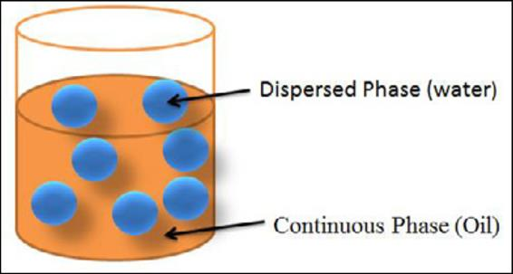

### Fig 1.1 water in oil emulsion type

* 1. **Characteristics of the light crude oil.**

|  |  |
| --- | --- |
| Density | 0.8628 (g/cm3) |
| Viscosity | 35 (N/m2) |
| API Gravity | 35 – 45 |
| Surface Tension | 13.678 (mN/m) |
| Interfacial Tension | 14.731 (mN/m) |
| Melting point | 23.50C |
| Boiling point | 180 - 360 |

**CHAPTER 2**

**LITRATURE REVIEW**

**Reza Zolfaghari et al., (2021) “Demulsification techniques of water-in-oil and oil-in- water emulsions in petroleum industry”**- The difficulties associated with transportation and refining of crude oil emulsions and produced water discharge limitations are among the conspicuous clues that have led the oilfield researchers to probe into practical demulsification methods for many decades. Inconsistent research outcomes observed in the literature for a particular demulsification method of a typical emulsion (i.e., water-in-oil or oil-in-water) arise not only from the varied influential parameters associated (such as salinity, temperature, pH, dispersed phase content, emulsifier/demulsifier concentration, and droplet size) but also from the diverse types of emulsion constituents (namely oil, surfactant, salt, alkali, polymer, fine solids, and/or other chemicals/impurities).

**Sofiah Atirah Raya1 et al., (2020) “A critical review of development and demulsification mechanisms of crude oil emulsion in the petroleum industry”-** The need for efficient demulsification process to treat emulsions in the petroleum industry is well acknowledged. For decades, numerous researches have been conducted to examine mechanisms of emulsification and demulsification. Untreated emulsion has both technical and commercial implications in the industry, especially in terms of treatment facilities, refining and transportation. Effective treatment is needed to ensure optimum production of hydrocarbons. The present paper is to review reported works on the formation of petroleum emulsions, demulsification treatments, characteristics of fit for-purpose demulsifiers as well as research trends in emulsion treatment. Crude oils are naturally combined with natural surfactants having high tendency to form stable emulsion. The stable emulsion must be treated well to meet industrial requirements since crudes with a high volume of stable emulsion have a less value.

**Alves et al. (2020) “Synthesis and application of castor oil maleate and castor oil maleate-styrene copolymers as demulsifier for water-in-oil emulsions” *–*** Castor oil maleate and castor oil maleate styrene copolymers were synthesized. Two different Brazilian crude oils, deionized water, sodium chloride, NaOH and HCl for synthetic emulsion formation. These were characterized by FTIR, SEC, and TGA. Bottle tests were carried out at 60 °C in graduated ASTM test tubes for 2 h, varying additive concentration from 100 to 5000 ppm. Interfacial tension

measurements were performed .These results were discussed on the basis of the oil characterization, mechanisms of demulsifying action, as well as interfacial tension data.

**Saad et al., (2021) “Synthesis, characterization, and demulsification of water in crude oil emulsion via a corn oil-based demulsifier”-** A corn oil-based demulsifier has been successfully synthesized. The demulsifier was characterized by FTIR, GC-MS, and LC-QTOF- MS analyses. The surfactant’s separation efficacy was studied using the Sany-glass test. The re2.sults showed that this new product efficiently demulsified the W/O emulsion with 98% separation achieved. The influence of settling time, demulsifier dosage, and temperature on the demulsification efficiency were investigated.

**Feitosa et al., (2019) “Synthesis and application of additives based on cardanol as demulsifier for water-in-oil emulsions”-** Ethoxylation and resins synthesis were based on hydrogenated cardanol. Three different Brazilian crude oils, deionized water, sodium chloride, NaOH and HCl for synthetic emulsion formation. These additives were characterized by FTIR and 1 H NMR analysis. Bottle test was done for water separability tests. These results were discussed on the basis of the oil characterization and effects of additives

**Javadian et al., (2020) “Demulsification of water in oil emulsion by surface modified SiO2 nanoparticle”-** SiO2 @ oleic acid (OA), SiO2 @ sodium dodecyl benzene sulfonate (SDBS) and GO-SiO2 nanocomposite was synthesized and was characterized with SEM, FESEM, BET, XRD, FT-IR, TGA, and zeta potential. The performance of nano demulsifiers was evaluated with bottle test. The effects of temperature and salt were surveyed Interfacial tension measurement, Total acid number determination, Viscosity measurement of the emulsions are done. These results were discussed on the basis of the oil characterization, temperature effect, salt effect and interfacial tension data.

**2.1 RESEARCH GAP**

Researchers in petroleum industry is trying to replace petroleum-based surfactants for natural demulsifiers, as a result of their low biodegradability that can cause hazardous risk to the ecosystem. Development of new surfactant molecules remains still a challenge for petroleum industry. Many researches have carried out in kerosene oil, castor oil based demulsifiers. As a first attempt lubricating oil is chosen for the demulsification process in this study.

**2.2 AIM**

To use lubricating oil as demulsifiers for demulsification of oil water emulsion in crude oil and to study the demulsifier efficiency.

### 2.3 OBJECTIVES

* To synthesize a lubricating oil based demulsifier to separate water from crude oil emulsion by demulsification method.
* To study the demulsification efficiency in the most stable emulsion (W/O emulsion) by examining the effects of the settling time, demulsifier dosage, temperature, the impact of additives and to measure the interfacial tension of emulsion by varying the concentration of demulsifier.
* To enhance the demulsification efficiency by passing the emulsion with demulsifier into the coalescer column by optimizing the parameters like demulsifier concentration, bed height and flow rate.
* To develop faster and efficient emulsion-breaking route, as well as impose less economic problems in the petroleum industry.

## CHAPTER 3

### 

### MATERIALS AND METHODS

**3.1 MATERIALS**

The Light crude oil sample was obtained from Chennai Petroleum Corporation Limited (CPCL), Chennai. the Lubricating oil was purchased from petrol bunk. Sodium chloride (NaCl) for brine preparation Emulsifing agent (cityl trimethyl ammonium bromide). , beakers, heating mantle, 10 mL centrifuge tubes for bottle test and water bath. Coalescer column, Condenser, beakers, measuring flasks and Heating mantle.

### 3.2 EMULSION PREPARATION

The water-in-oil (W/O) emulsions were prepared at volumes of (30/70) vol.%. This work then used a homogenizer (IKA, Ultra Turax T25 Basic) at a mixing rate of 1000 rpm for 30 min at room temperature. Domestic tap water was used as the dispersed phase, and crude oil served as the continuous phase. The agent was followed in the oil process, i.e., the emulsifying agent was dissolved in the continuous step (oil). Water was slowly added to the mixture (oil + emulsifier). The cityl trimethyl ammonium bromide product used as emulsifier produced a stable emulsion

### 3.3 SYNTHESIS OF LUBRICATING OIL BASED RESINS

The two-step alcoholysis–polyesterification synthesis was carried out by maintaining its desired temperature at each step in a nitrogen atmosphere using a mechanical stirrer. A volume of 38.68 g of lubricating oil was taken in a three-necked round bottom flask of 100 mL, 7.36 g of glycerol and 0.05 wt% (based on oil) of NaOH was added to the oil. The reaction mixture was then stirred continuously for 1 h at a constant temperature of 230 °C and a constant speed of 1000 rpm (rounds per min). A small amount of resultant monoglyceride was removed and mixed with methanol; the complete dissolution of the mixture confirms the formation of monoglyceride in the product. After the monoglyceride test, the temperature of the reaction mixture was lowered to 120 °C prior to the addition were added to the mixture, and the 0.12 mol of finely ground acid anhydride and 1.98 g of glycerol were added to the mixture, and the temperature was raised up to 220 °C. The mixture was quenched till the temperature reached 25 °C, and the resin was poured in the sample holder. Curing of the alkyd resins was carried out by blending with epoxy resin .2 g of the resin was blended with 1.33 g of epoxy resin, 0.6 g of epoxy hardener in a Petri dish and stirred manually for 10 min.

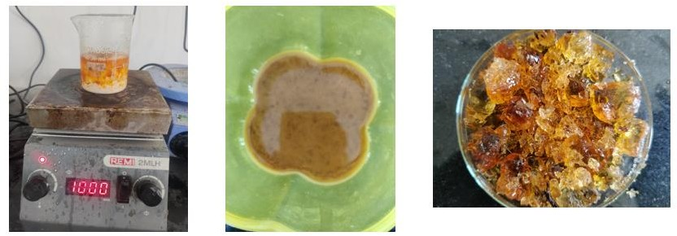

**Fig 3.1 lubricating oil based resins**

### 3.4 EXPERIMENTAL SETUP COALESCENCE FLOW TEST

The Construct a coalescence column of 25 cm in height and diameter of 18 cm. Pack the coalescence column by adding porous particles into the bed holder. Connect the pump, emulsion tank, coalescence column, and settling unit. Pump 1000 mL of the emulsion, at 10 ml /min, to flow through the coalescence column. Keep the collected oil and water in the settling unit, at the same temperature, for 4 hours to allow water droplets to settle by gravity. Take an oil sample from the oil layer in the settling unit for determining water content of the oil (1) Stirrer, (2) mixing vessel, (3) peristaltic pump, (4) inlet of emulsion, (5) resin bed (Moses, S. F., & Ng, K. M.,1985).

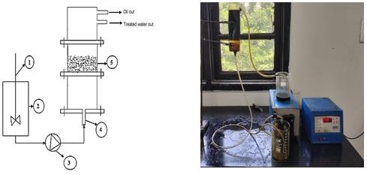

**Fig 3.2 experimental setup in coalescence column**

**3.5 INSTRUMENTAL ANALYSIS**

The prepared demulsifier, packing material and emulsion was analysed by using FTIR, GC-MS and SEM analysis. The added amine functionality that access demulsifier was confirmed through FTIR an GCMS analysis. The morphology of the emulsion and presence of moisture content was found through SEM analysis.

## CHAPTER 4

### RESULTS AND DISCUSSION

**4. CHARACTRAIZATION**

**4.1** **FOURIER TRANSFORM INFRARED SPECTROSCOPY**

The objective of Fourier Transform Infrared study was to determine the functional groups present in the crude oil. Using an Agilent Cary 630 spectrometer, Fourier Transform Infrared Spectroscopy (FTIR) was used to evaluate the unprocessed neem oil and the synthetic neem oil-based demulsifier. With a spectral resolution of 1 cm1, the FTIR spectrum was acquired spanning the wavenumber range of 400–4000 cm1 (Babu K et al. 2015).

The most intense peaks present at 2924 cm−1 and 2854 cm−1 (C-H) represent single bonded alkanes while 671 cm

−1 (C=C)represent double bonded alkenes. Presence of aromatics, carboxylic acid, alcohol amines, amides, nitro compounds, halides and esters at wave numbers 1458 cm−1 (C-H), 2361 cm−1 (C-O), 1088 cm-1 (C=O),2924 cm−1 (C-N), 1564 cm−1 (N=O), 1774 cm−1 (C=O) and 1744 cm−1 (C=O) respectively.

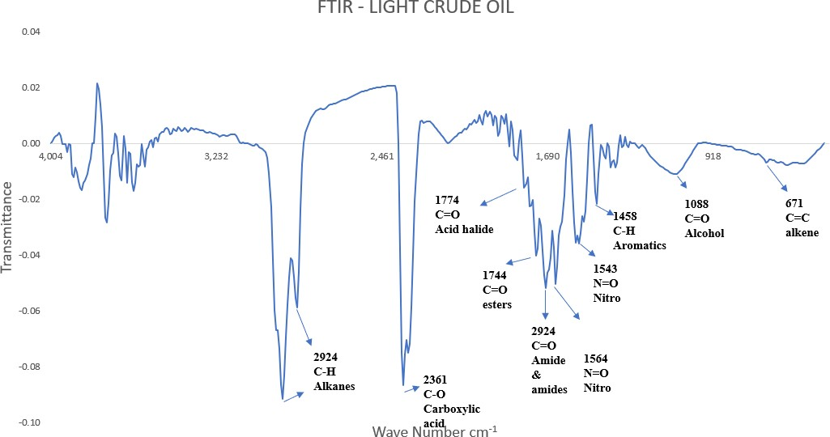

**Fig 4.1 Fourier Transform Infrared Spectroscopy (FTIR)- Light Crude Oil**

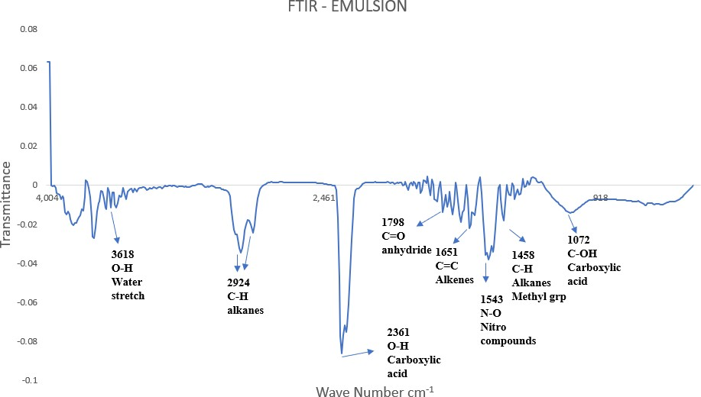

**Fig 4.1.1 Fourier Transform Infrared Spectroscopy (FTIR) – crude oil emulsion**

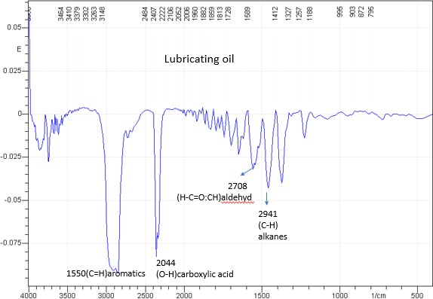

**Fig 4.1.2 Fourier Transform Infrared Spectroscopy (FTIR)- lubricant oil**

The intense peaks present at 2924 cm−1 (C-H) represent single bonded alkanes and 1458 cm-1 (C-H) methyl group. O-H water stretch is shown by the peak 3618 cm-1 which confirms the presence of water. The peaks 2361 cm-1 and 1072 cm-1 represent the carboxylic acid group (C-OH) stretch. The peak at 1798 cm-1 (C=O) represent anhydride. The peak at 1543 cm-1 represent nitro (N=O).

The intense peaks present at 2941 cm-1 (C-H) represent single bonded alkanes and2708cm-1 (H-C=O:CH) Aldehyd. The peaks 1541cm-1 (C=H) aromatics. The peak at 2044cm-1 (O-H) carboxylic acid (Javadian, Soheila, et al 2020).

### 4.1.1 SEM ANALYSIS FOR EMULSION SAMPLE

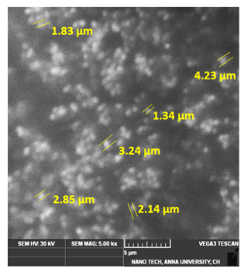

**Fig 4.2 SEM image for Stable emulsion sample**

A scanning electron microscope was used to examine a synthetic emulsion. A stable emulsion is produced by water droplets with a size between 1 and 100 μm. It was observed that the emulsions with the smaller particle sizes were more stable than their larger counterparts. The emulsions with an average particle size of 1-5 μm were found to be stable even after 30 days at 60°C. The smaller the droplet size the larger the stability of emulsion (S. Morteza Sadrpoor et al 2020).

**4.1.2 GC-MS ANALYSIS OF DEMULSIFIER**

After introducing the sample into an Agilent 7890 gas chromatograph connected to a 5973 quadruple mass spectrometer, the synthesised demulsifier was subjected to gas chromatography-mass spectroscopy (GC-MS) examination. There were 25 100% composition composites. The identified compounds are included in Table 1 along with their retention time (RT), composition rate, and molecular formula as determined by PubChem. The surfactant's GC-MS characterisation in terms of retention time (min) and chemical abundance is displayed in Fig. 4. Esters, amines, hydrocarbons, carboxyles, amides, and fatty acids were among the substances discovered ( Biswadeep, et al. 2021). Due to their high molecular weight, which acts as a flocculant in adsorption and contact activities, amines and fatty acids are present in high concentrations, aiding in the demulsification process.

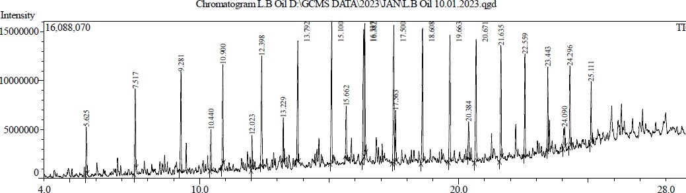

**Fig. 4.3 GC-MS of lubricating oil in terms of retention time an intensity**

**Table 4.1 Components present in lubricating oil by GC-MS**

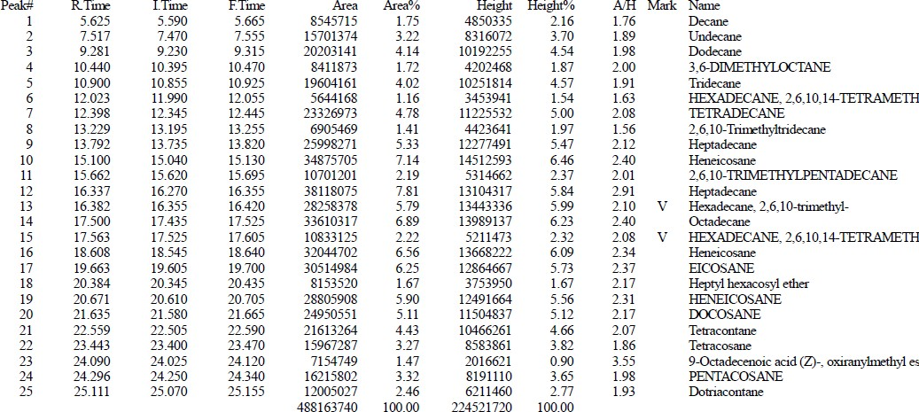

**4.2 PATERAMETRIC OPTIMIZATION – BOTTLE SEPARATION METHOD**

To better understand the demulsification efficiency of the most stable emulsions (W/O emulsions), the influence of the settling time, demulsifier dosage, and temperature on demulsification efficiency was evaluated. The results obtained for lubricating oil based demulsifier is compared with chemical octylamine demulsifier.

**4.2.1 EFFECT OF DEMULSIFIER DOSAGE ON THE SEPARATION PERFORMANCE**

Higher demulsifier concentrations are necessary for treating more stable emulsions, however using too little demulsifier could cause the emulsion to disintegrate rather than stabilise. In a total volume sample of 10 ml (4 times), a 3:7 (vol%) water-in-oil emulsion was created. The formation of small, homogeneous emulsion droplets that enable emulsion stability is visible in the SEM pictures (Tarun Kumar Naiya et al 2021). The demulsifier's effectiveness at breaking apart emulsions was evaluated using a bottle test. To make the emulsion, 10 mL of various demulsifier concentrations (0.5-2 mL) were added. The tubes are kept in a 50oC water bath. Equation (1) was used to calculate the percentage of water separation efficiency (SE%) from the observed volume of water in the graduated measurement container in mL.

Separation efficiency (SE%) = volume of collected in ml

𝑂𝑟𝑖𝑔𝑖𝑛𝑎𝑙 𝑣𝑜𝑙𝑢𝑚𝑒 𝑜𝑓 𝑤𝑎𝑡𝑒𝑟 𝑖𝑛 𝑡ℎ𝑒 𝑒𝑚𝑢𝑙𝑠𝑖𝑜𝑛 𝑖𝑛 𝑚𝐿

(1)

It was noted that the separation of phases was a function of time. These findings suggested that as demulsifier concentration rises, more demulsifier molecules are deposited on the water-oil interface, taking the place of natural asphalt emulsifiers. This reduces the interfacial film's mechanical stability (E. Drickison, et al 1992). This film's stability begins to decrease until it is weaker and then collapses entirely with more demulsifier agent adsorption on the interface

**Table 4.2 Demulsification dosage and separation efficiency**

|  |  |  |  |  |  |  |  |  |  |  |
| --- | --- | --- | --- | --- | --- | --- | --- | --- | --- | --- |
|  |  | **0.5 Ml** | | **1 mL** | | **1.5 mL** | | **2 mL** | | **Average Separati on Efficienc**  **y %** |
| **Tim e (hr)** | **Blan k** | **Water separat ed mL** | **SE**  **%** | **Water separat ed**  **mL** | **SE**  **%** | **Water separat ed**  **Ml** | **SE**  **%** | **Water Separat ed** | **SE**  **%** |
| 6 | 0 | 0 | 0 | 0.3 | 10 | 0.5 | 16.6 | 0.8 | 26.6 | 13.33 |
| 12 | 0 | 0.2 | 6.66 | 0.4 | 13.3 | 0.7 | 23.3 | 1 | 33.3 | 19.14 |
| 18 | 0 | 0.3 | 10 | 0.6 | 20 | 0.8 | 26.6 | 1.2 | 40 | 23.08 |
| 24 | 0 | 0.5 | 16.6 | 0.8 | 26.6 | 1 | 33.3 | 1.5 | 50 | 31.66 |
| 30 | 0 | 0.7 | 23.3 | 1 | 33.3 | 1.3 | 43.3 | 1.8 | 60 | 39.99 |
| 36 | 0 | 0.8 | 26.6 | 1.1 | 36.6 | 1.6 | 53.3 | 2 | 66.6 | 45.79 |
| 42 | 0 | 0.9 | 30 | 1.3 | 43.3 | 1.8 | 60 | 2.2 | 73 | 51.58 |



**SEPARATION EFFICIENCY%**

Blank

0.5 ml

1ml

1.5ml

2ml

80

70

60

50

40

30

20

10

0

6

12

18

24

TIME (HR)

30

36

42

SEPARATION EFFICIENCY %

**Fig 4.4 Separation efficiency of demulsifier vs demulsifier doses**

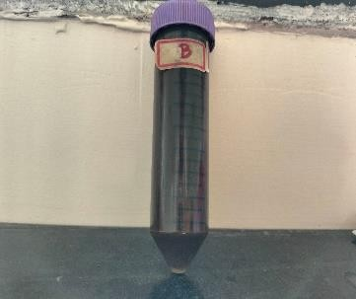 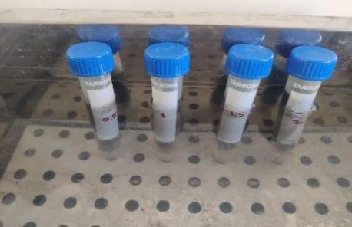 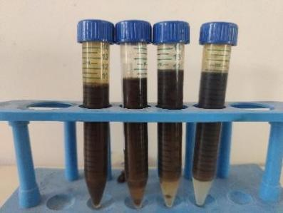

* + 1. **(b) (c)**

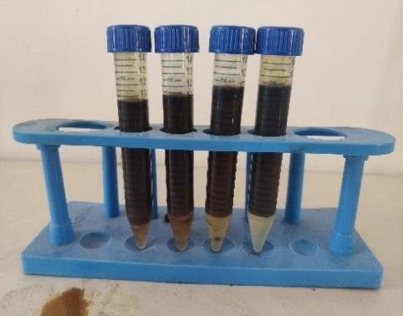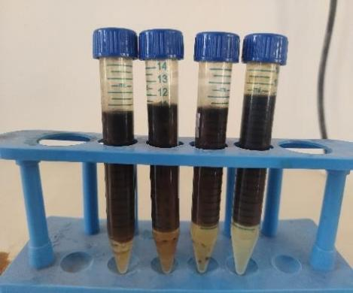

**(d) (e)**

**Fig 4.4.1 (a) stable blank emulsion, (b) tubes maintained at 50oC in water bath, (c) demulsification at 6 h period, (d) demulsification at 24 h period, (e) demulsification at 42 h period.**

**4.2.2 EFFECT OF SETTLING TIME**

The average separation efficiency as a function of time achieved during four different concentrations (0.5-2 mL) of lubricating oil. The findings showed that when settling time rose, there was a greater separation of water. (T. N. Poyarkova et al. 2010). Since there are less water droplets in the emulsion as time goes on, the separation rate drops. As a result, water molecules disperse and lessen the likelihood of water droplets colliding and coalescing. According to Raynel G. et al.2021, the amount of water separated grows as the settling time increases. For each concentration, there is more water separated at the end of 42 hours. The results indicated that settling time is a significant factor affecting demulsification efficiency.



**AVERAGE SEPARATION EFFICIENCY%**

60

50

40

30

20

10

0

6

12

18

24

TIME (HR)

30

36

42

average separation efficiency% Blank

**Fig 4.5 Average separation efficiency (%) of emulsion vs time (h)**

SEPARATION EFFICIENCY %

**4.2.3 INFLUENCE OF TEMPARATURE ON THE SEPARATION PERFORMANCE**

The emulsion can also be demulsified using heat. The demulsification process is one of many chemical processes where temperature is important. Factors that hinder crude oil's capacity to create the film can affect the stability of the emulsions (Kokal S, et al 2019).The viscosity of these films can then be continuously reduced by raising the temperature, which facilitates the kinetic motion of the dispersed water droplets. This causes the film to relax more, rupture, and coalesce more, as well as change its physical properties. heating's impact on the demulsification procedure. With a change in temperature, the amount of water that progressively separated from the emulsion increased. The process of separating the water from the emulsion was faster than the experiments conducted at room temperature. Same amount of demulsifier concentration of 2.5 mL was applied to every 10 mL of the emulsion prepared. By keeping the demulisifier dosage, volume constant the temperature of the water bath was varied (70°C , 80°C and 90°C).

It was noted that the separation of phases was a function of time. Results show the emulsion's ability to separate as a function of temperature when lubricating oil is applied to act as a demulsifier. The separation efficiency was shown in the figure to rise with temperature, and water separated more quickly than in studies done at room temperature (Zhang H, et al 2015). As previously mentioned, when the temperature was raised from 70 °C to 90 °C, the amount of water eliminated increased significantly within the first 6 h and then gradually until demulsification was complete. The values then reached 94 and 96% at temperatures of 70 and 80 °C. No further separation was seen during this period. Same procedure is followed with using additive added lubricating oil as demulsifier of 2.8 mL concentration by varying temperature from 80 to 90°C. The highest value 98% was obtained at the 42 h period at 90°C itself i.e., it got separated at the faster rate than the lubricating oil demulsifier. The demulsification of water in an oil emulsion is supported by heating. The time required for settling was shortened by the use of heat during the demulsification of the emulsion.

**Table4.3 Influence of temperature for lubricating oil demulsifier at varying temperature (70°C, 80°C, and 90°C)**

|  |  |  |  |  |  |  |  |
| --- | --- | --- | --- | --- | --- | --- | --- |
|  |  | **70°C** | | **80°C** | | **90°C** | |
| **Time (hr)** | **Blank** | **Water separated** | **SE%** | **Water separated** | **SE%** | **Water separated** | **SE%** |
| **mL** | **mL** | **mL** |
| **0** | 0 | 0 | 0 | 0 | 0 | 0 | 0 |
| **6** | 0 | 1.2 | 42.6 | 1.4 | 48.2 | 1.5 | 51.4 |
| **12** | 0 | 1.5 | 53.3 | 1.7 | 57.9 | 1.9 | 63.7 |
| **18** | 0 | 1.8 | 63.1 | 2 | 69.3 | 2.2 | 74 |
| **24** | 0 | 2 | 69.2 | 2.3 | 76.5 | 2.4 | 83 |
| **30** | 0 | 2.3 | 76.9 | 2.5 | 85.3 | 2.6 | 89.1 |
| **36** | 0 | 2.6 | 87.1 | 2.7 | 91.1 | 2.8 | 98.2 |
| **42** | 0 | 2.7 | 94 | 2.8 | 96 | 2.9 | 98 |



**TEMPERATURE SEPARATION EFFICIENCY%**

120

100

80

60

40

20

0

6

12

18

24

TIME

30

36

42

blank 70 80 90

SEPARATION EFFICIENCY %

**Fig 4.6 Influnce of temperature for separation efficiency**.

**4.2.4 INTERFACIAL TENSION MEASUREMENT**

The effect of lubricating oil on interfacial tension between crude oil-water emulsions. The interfacial tension of the oil–water interface at various dosed tested at 25 °C with pendant drop test consisted of calculating the IFT of a droplet of crude oil produced in a phase of water. IFT result have been calculated and recorded in Table 4. The crude oil/ water interfacial tension was

13.8 mN/m. With the addition of various demulsifier concentrations, interfacial tension decrease was obtained down to 3 mN/m at 4 mL of lubricating oil surfactant which is shown in table 4 the demulsifier occupied in interfacial layer decreases the film strength and accelerate the separation (Hassan, Faheem, et al.2018).

**Table 4.4 Interfacial Tension for lubricating oil**

|  |  |  |
| --- | --- | --- |
| Demulsifier | Dosage  (ml) | IFT  (mN/m) |
| Blank | 0 | 13.8 |
| Demulsifier | 1 | 10.1 |
|  | 2 | 9.2 |
|  | 3 | 6 |
|  | 4 | 4 |

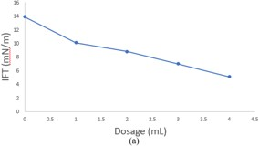

**Fig 4.7 IFT (mN/m) vs Dosage (mL) for lubricating oil surfactant**

**4.2.5 EFFECT OF SALINITY**

The effect of salinity on demulsification efficiency played a crucial role in between oil-water interfaces. Increasing in salinity create a separate phase by lowering the emulsion stability which improve its portioning behavior and coalescence of water droplet. After reaching the optimum separation at a particular salt concentration, higher salt concentration increases the emulsion stability. As a result slightly less separation of water was found (Raissa S., et al 2020).

|  |  |  |  |  |
| --- | --- | --- | --- | --- |
| SALINITY  6 5.6  5  4 3.5  3  2  1.4  1 0.5 0.75  0.25 | | | | |
|  | | 1 | 2 | 3 |
|  | salinity | 0.25 | 0.5 | 0.75 |
| SE% | 1.4 | 3.5 | 5.6 |
| salinity SE% | | | | |

0

**Fig 4.8 Effect of salinity for separation efficiency**

**4.3 SCANNING ELECTRON MICROSCOPE FOR BED**

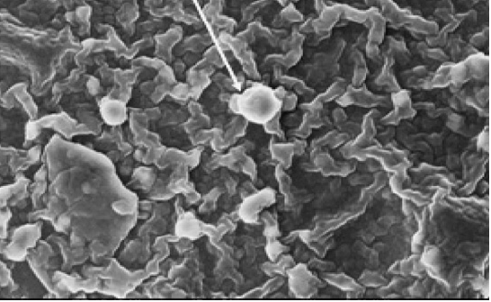

**Fig 4.9 SEM for lubricating oil based resin bed**

The resin material is composed of hydrophobic core and hydrophilic outer shell. When

the emulsified oil passed through the resin bed, the emulsified oil particles interacted with the

hydrophilic part of the resin. As a result, the emulsified oil molecules adsorbed over the resin

surface and formed a film covering the resin surface. This film is clearly seen in the SEM

micrograph of the regenerated resin (Basu. S et al.,1993)

**4.4 EFFECT OF FLOW RATE**

The effect of the flow rate in the range from 60 ml/min on the removal efficiency at an influent oil concentration of 5000 ppm and a bed height of 12 cm. with an increase in the flow rate, the oil removal efficiency decreased. The removal efficiencies of oil were found to be 16, 13, 8, 5.6, 2.4, 0.4% for emulsion flow rates of 60, 50, 40, 30, 20 and 10 ml/min, respectively. Attraction of oil droplets from the bulk emulsion phase to the droplets attached to the resin surface. This facilities the coalescence of oil droplets and the removal efficiency of oil gets improved. As the flow rate increases, the contact time decreases, and the coalescence is adversely affected due to upward of the flow. This reduces the efficiency of oil removal from the emulsion (Zhou, Y. B et al., 2009).

Water content in oil (%) = x 100

**Table 4.5 flow rate ml/min vs water content %**

|  |  |  |
| --- | --- | --- |
| Flow rate ml/min | Water collected ml | Water content % |
| 60 | 8 | 16 |
| 50 | 6.5 | 13 |
| 40 | 4 | 8 |
| 30 | 2.8 | 5.6 |
| 20 | 1.2 | 2.4 |
| 10 | 0.2 | 0.4 |

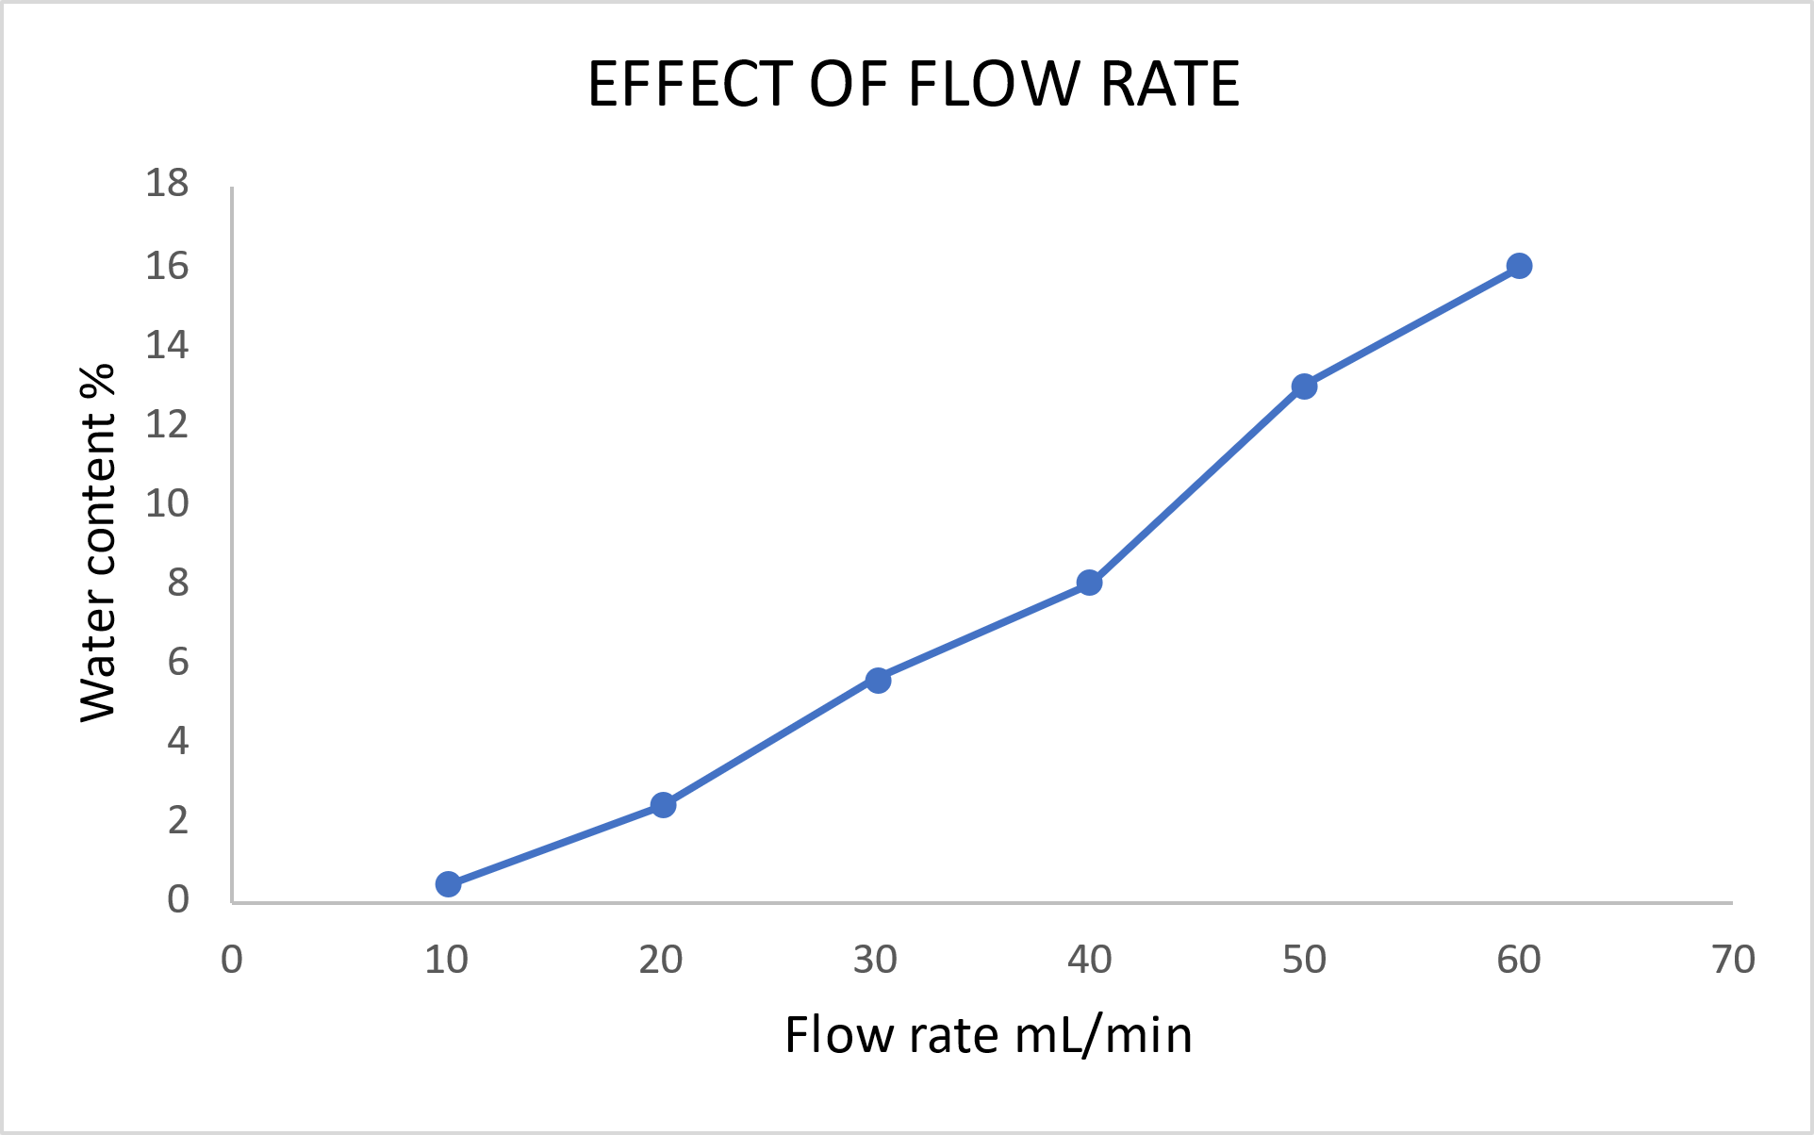

**Fig 4.10 Effect of flow rate**

**4.4.1 EFFECT OF BED HEIGHT**

The effect of bed height on calculating the water content present in the collected oil was studied at an influent demulsifier concentration of 10000 ppm and a flow rate of 10 mL/min. At any flow rate bed height is directly proportional to the contact time between the bed and the flowing emulsion (Li, Y et al., 2016) The bed height should be sufficient for providing adequate and satisfactory contact time between the lubricating oil based resin and the emulsion for droplets to coalescence. Fig. shows the effect of bed height on water content %. As the bed height increased from 3 cm to 11 cm the water content % present in the collected oil was found to be decreased (Maiti S et al., 2009)

**Table 4.6 bed height cm vs water content %**

|  |  |  |
| --- | --- | --- |
| Bed height (cm) | Water collected ml | Water content % |
| 3 | 12 | 24 |
| 5 | 9 | 18 |
| 7 | 7.4 | 14.8 |
| 9 | 4.2 | 8.4 |
| 11 | 1 | 2 |



**Fig 4.11 Effect of bed height**

**4.4.2 EFFECT OF TEMPERATURE IN COALSCENCE COLUMN**

To increase the temperature of emulsion in 700c, 800c and 900c. for separation and using the peristaltic pump is discharge to the emulsion into coalescence column. The heated emulsion has contact with lubricating oil based resin bed.and finally to get the outlet and to calculate the water content % from the outlet sample. The water content% decreased with increased in temperature (Saad, M. Aet al., 2021)

**Table 4.7 bed height (cm) vs Temperature**

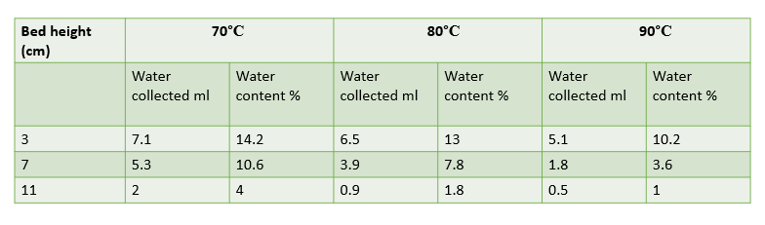

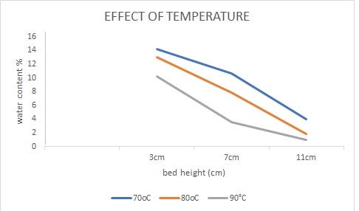

**Fig 4.12 effect of temperature**

**4.5 DETERMINATION OF DENSITY OF THE EMULSION**

Using a specific gravity bottle and distilled water as the foundation liquid, the density of the emulsion was calculated as follows:

Weight of empty specific gravity bottle (W1) = 20.58 g

Weight of specific gravity bottle + Distilled water (W2) = 50.59 g

Weight of specific gravity bottle + Sample Liquid = 50 g

Density of emulsion (ρ2) =

ρ2  =

ρ2 = = 0.980 g/ml

Density of Emulsion (ρ2) = 0.980 g/ml

Density of distilled water at room temperature (ρ1) = 0.997 g/ml

**4.5.1 DETERMINATION OF VISCOSITY (OSTWALD VISCOMETER)**

Viscosity of the emulsion with demulsifier was determined by using Ostwald Viscometer as follow:

Viscosity of Emulsion (μ2) = x μ1

ρ1 = Density of water ( 0.997 g/ml)

ρ2 = Density of emulsion ( 0.980 g/ml)

μ1 = Vicosityof water (cP)

μ2 = Viscosityof emulsion (cP)

t1 = Mean time of flow of water from A to B

t2 = Mean time of flow of emulsion from A to B

|  |  |  |  |
| --- | --- | --- | --- |
| **Liquid Sample** | **Mean Time (sec.)** | **Density (ρ) g/ml** | **Viscosity cP** |
| Distilled Water | t1 = 20 | 0.997 | 0.8937 |
| Emulsion | t2 = 52 | 0.980 | 2.2883 |

Viscosity of distilled water(μ1) = 0.8397 cP

Viscosity of emulsion (μ2) = 2.283 cP

**4.5.2 DETERMINATION OF POROSITY**

Porosity is a measure of the pore volume. It is either expressed as a percentage or fraction. The minimum range of porosity is 0.3 to 0.6,

Porosity (Φ) =

Total volume = πr2 h

= (3.14) (3.5)2 (25)

= 961.625

Volume of bed = πr2 h

= (3.14) (3.5)2 (9)

= 346.185

Porosity (Φ) =

**Φ = 0.64**

**4.5.3 DETERMINATION OF SPHERICITY**

Sphericity is a measure of how spherical an object is. If the value is 1 then it is a perfect sphere.

**Sphericity of the particle =**

Volume of one particle = weight/density

= 0.2/2.3

= 0.0869

Equivalent diameter = 4mm

Sphericity of the particle = 6 (0.0869)/4

**ψ= 0.13**

**4.5.4 DETERMINATION OF SUPERFICIAL VELOCITY**

The velocity of a fluid moving to the column, If change or increase in radius of the bed with decrease the superficial velocity. Pressure drop and superficial velocity are inversely proportional to each other. if superficial velocity decreases, the pressure drop increases.

**Vo =**

ρ w - Density of water

ρ e - Density of emulsion

R - Radius of the column

**Vo =**

**Vo = 0.304 m/s**

**4.5.5 PRESSURE DROP ACROSS THE COALESCER BED**

The pressure drop across the coalescing beds is calculated by using the Kozeny Carmen equation for the w/o emulsion flow through a coalescing bed with an intermediate porosity (0.3–0.6). The general Kozeny Carmen equation for predicting the pressure drop across a coalescing bed is given as follows

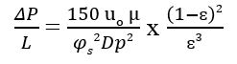

fig. 5 shows the pressure drop of coalescer column against emulsion viscosity. The experimental data have been fitted with Kozney Carmen equation by using the values of porosity (ɛ), emulsion viscosity (μ), average particle diameter (Dp), Sphericity of the particle () and the superficial velocity (u0) of the emulsion (M. Belkacemi, et al 2007). It is clear from table 4.8 and fig 4.13 that/ pressure drop in the coalescer column increases linearly with increase in the viscosity

|  |  |  |
| --- | --- | --- |
| **S. NO** | **Flow rate ml/min** | **Pressure drop (ΔP/L) Pa/m** |
| 1 | 10 | 1409.18 |
| 2 | 20 | 2912.30 |
| 3 | 30 | 4415.43 |
| 4 | 40 | 5918.56 |
| 5 | 50 | 7421.69 |
| 6 | 60 | 8924.81 |
| 7 | 70 | 10427.94 |
| 8 | 80 | 11931.07 |
| 9 | 90 | 13434.19 |
| 10 | 100 | 14937.32 |

**Table 4.8 Superficial velocity and Pressure drop of coalescer bed**

**Fig 4.13** **flow rate ml/min vs pressure drop pa/m**

## CHAPTER 5

**CONCLUSION**

This article's main goal is to employ an environmentally friendly demulsifier to break the emulsion in order to increase water separation. An artificial emulsion was created. FTIR, GC-MS, and SEM analyses of the emulsion sample were used to describe the demulsifier and see how water glubules dispersed in the crude oil. Demulsification efficiency of the most stable emulsions (W/O emulsions) was assessed, along with the effects of temperature, settling time, and demulsifier dosage. In comparison to the traditional lubricating oil demulsifier, the demulsifier demonstrated effective separation performance at a reduced settling time at a faster pace. The demulsification process is sped up and separation efficiency is improved when heating the emulsion. Studies measuring interfacial tension (IFT) show that the IFT decreases as demulsifier dosage is raised. The demulsifier performed incredibly well at separating water.the emulsified oil molecules adsorbed over the resin surface and formed a film covering the resin surface. It was used as packing materials in coalescence column to increase the efficiency of W/O emulsion. Experiment were conducted by changing the parameters like bed height of packing material, flow rate and temperature of the emulsion which is sent inside the coalescence column. As the bed height increased from 3 cm to 11 cm the water content % present in the collected oil was found to be decreased. As the flow rate increases, the contact time decreases, and the coalescence is adversely affected due to upward of the flow. The water content% decreased with increased in temperature. Pressure drop in the coalescer bed was calculated and it increases linearly with increase in the viscosity and flow rate.

**REFERENCE**

1. Alves, Raissa S., et al. "Synthesis and application of castor oil maleate and castor oil maleate-styrene copolymers as demulsifier for water-in-oil emulsions." Fuel 269 (2020): 117429.
2. Feitosa, Filipe X., Raissa S. Alves, and Hosiberto B. de Sant'Ana. "Synthesis and application of additives based on cardanol as demulsifier for water-in-oil emulsions." Fuel 245 (2019): 21-28.
3. Hassan, Faheem, et al. "Use of Neem leaves for oil removal from waste water." Pakistan Journal of Engineering and Applied Sciences (2018).
4. Saad, M. A., et al. "An overview of recent advances in state-of-the-art techniques in the demulsification of crude oil emulsions." Processes 7.7 (2019): 470
5. Saad, M. A., N. H. Abdurahman, and Rosli Mohd Yunus.   "Synthesis, characterization, and demulsification of water in crude oil emulsion via a corn oil-based demulsifier." Materials Today: Proceedings 42 (2021): 251-258
6. Javadian, Soheila, and S. Morteza Sadrpoor. "Demulsification of water in oil emulsion by surface modified SiO2 nanoparticle." Journal of Petroleum Science and Engineering 184 (2020): 106547.
7. Pal, Biswadeep, Rahul Kumar, and Tarun Kumar Naiya. "Demulsification of crude oil-water emulsion using naturally formulated demulsifier." Petroleum Science and Technology 39.21-22 (2021): 1027-1042
8. Parineeta Das Namita Sharma Amrit Puzari Dilip Kumar Kakati Nirmala Devi1Synthesis and characterization of neem (Azadirachta indica) seed oil‐based alkyd resins for efcient anticorrosive coating application (2021).
9. Soumitra Maiti∗,1, et al Removal of oil from oil-in-water emulsion using a packed bed of commercial resin (2011).
10. Ministry of Environment and Forests Notification, Environment (Protection) Amendment Rules, 2008, (Petroleum oil Refinery) G.S.R. 186(E), 18/03/2008, India.
11. P. Ca˜nizares, F. Martínez, J. Lobato, M.A. Rodrigo, Break-up of oil-in-water emulsions by electrochemical techniques, J. Hazard. Mater. 145 (2007) 233–240.
12. E. Drickison, Interfacial interaction and the stability of oil-in-water emulsions, Pure Appl. Chem. 64 (1992) 1721–1724.
13. A.A. Hazif, H.M. Ei-Din, A.M. Badawi, Chemical destabilization of oil-in-water emulsion by novel polymerized diethanolamines, J. Col. Inter. Sci. 284 (2005) 167–170.
14. K. Bensadok, M. Belkacemi, G. Nezzal, Treatment of cutting oil/water emulsion by coagulation and dissolved air flotation, Desalination 206 (2007) 440–448.
15. J.M. Benito, G. Rios, C. Pazos, J. Coca, Methods for separation of emulsified oil from water: a state-of-the-art-review, Trends Chem. Eng. 4 (1998) 203–231.
16. A. Cambiella, E. Ortea, G. Rios, J.M. Benito, C. Pazos, J. Coca, Treatment of oilin-water emulsions: performance of a sawdust bed filter, J. Hazard. Mater. 131 (2006) 195–199.
17. G.N. Mathavan, T. Viraraghavan, Use of peat in the treatment of oily waters, Water Air Soil Pollut. 45 (1989) 17–26.
18. G.R. Alther, Organically modified clay removes oil from water, Waste Manage.15 (1995) 623–628.
19. Viraraghavan, H. Moazed, Removal of oil from water by bentonite, Fresenius Environ. Bull. 12 (2003) 1092–1097.
20. Rogues, Y. Aurello, Oil–water separations: oil recovery and oily wastewater treatment, Kluwer Academic Publisher, Netherlands, 1991, pp. 155174.
21. Y.B. Zhou, X.Y. Tang, X.M. Hu, S. Fritschi, J. Lu, Emulsified oily wastewater treatment using a hybrid-modified resin and activated carbon system, Sep. Purif. Tech. 63 (2008) 400–406.
22. J. Li, Y. Gu, Coalescence of oil-in-water emulsions in fibrous and granular beds, Sep. Purif. Tech. 42 (2005) 1–13.
23. B. Zhou, L. Chen, X. MengHu, J. Lu, Modified resin coalescer for oil-in-water emulsion treatment: effect of operating conditions on oil removal performance, Ind. Eng. Chem. Res. 48 (2009) 1660–1664.
24. R. Ivanova, B. Balinov, R. Sedev, D. Exerowa, Formation of a stable, highly concentrated O/W emulsion modeled by means of foam films, Colloids Surf. A 149(1999) 23–28.
25. Y. Xu, Q. Wang, X. Hu, C. Li, X. Zhu, Characterization of the lubricity of biooil/diesel fuel blends by high frequency reciprocating test rig, Energy 35 (2010)283–287.